
SRM Institute of Science and Technology
SET A
College of Engineering and Technology
School of Computing
SRM Nagar, Kattankulathur – 603203, Chengalpattu District, Tamilnadu
Academic Year: 2022-23 (EVEN)
Test: CLA-T1 Date: 10.02.2023
Course Code & Title: 18CSC205J - Operating Systems Duration: 50 Minutes
Year & Sem: II Year / IV Sem Max. Marks: 25

Course Articulation Matrix: (to be placed)
S.No | Course Outcome | PO1 | PO2 | PO3 | PO4 | PO5 | PO6 | PO7 | PO8 | PO9 | PO10 | PO11 | PO12 | PSO1 | PSO2 | PSO3
1 | CO1 | 3 |  | 3 |  |  |  |  |  |  |  |  |  | 2
2 | CO2 | 2 | 1 | 3 |  |  |  |  |  |  |  |  |  |  | 2
3 | CO3 | 3 | 2 | 2 |  |  |  |  |  |  |  |  |  | 2
4 | CO4 | 3 | 2 | 2 |  |  |  |  |  |  |  |  |  |  | 2
5 | CO5 | 3 |  | 2 | 2 |  |  |  |  |  |  |  |  | 2

Part - A
(10 x 1 = 10 Marks)
Instructions: Answer all
Q. No | Question | Mark | BL | CO | PO | PI Code
 | A process stack does not contain __________  A. Function parameters  B. Local variables  C. Return addresses  D. PID of child process  Answer: D. PID of child process | 1 | 2 | 1 | 1 | 1.6.1
 | Which module gives control of the CPU to the process selected by the short-term scheduler?  A. dispatcher  B. interrupt  C. scheduler  D. resource management  Answer: A. dispatcher | 1 | 1 | 1 | 1 | 1.6.1
 | In a time-sharing operating system, when the time slot given to a process is completed, the process goes from the running state to the __________  A. Blocked state  B. Ready state  C. Suspended state  D. Terminated state  Ans: B. Ready State | 1 | 2 | 1 | 1 | 1.7.1
 | A process executes the following code  for (i = 0; i < n; i++)  fork ();  The total number of child processes created is  A. n  B. 2n - 1  C. 2n  D. 2(n+1) – 1  Ans: B. 2n – 1 | 1 | 2 | 1 | 1 | 1.7.1
 | What provides an interface to access the services of the operating system?  A) API  B) System call  C) Library  D) Assembly instruction  Answer B System Call | 1 | 1 | 1 | 1 | 1.6.1
PART B – 10 Marks
Answer any Two Questions
 | How the operating system has been evolved from serial processing to multiprogramming system. Describe in detail.  Key:  Early Batch Processing System: 3 marks  Multiprogramming system : 3.5 marks  Time Sharing system: 3.5 marks | 10 | 2 | 1 | 3 | 3.6.1
 | - Explain different operations on processes with an example for each.  Key:  Process creation: 2 marks  Process Termination: 2 marks  Example: use of fork() and exit() system call. 1mark  - Instructions related to accessing I/O devices are typically privileged instructions, that is, they can be executed in kernel mode but not in user mode. Give a reason why these instructions are privileged.  Ans:  - Because of privileged instructions Operating system could check whether a given user is authorized to do that I/O operation or not, before performing I/O.  - If I/O is not privileged, then user program can write into the disk which results in destroying all the disk resident OS and some other application programs | 5  5 | 2  3 | 1  1 | 1  3 | 1.7.1  3.7.1
 | Discuss in detail the critical section problem and write the algorithm for producer consumer problem.  Ans:  Critical Section refers to the segment of code or the program which tries to access or modify the value of the variables in a shared resource. If multiple processes access the critical section concurrently, then results produced might be inconsistent (3marks)  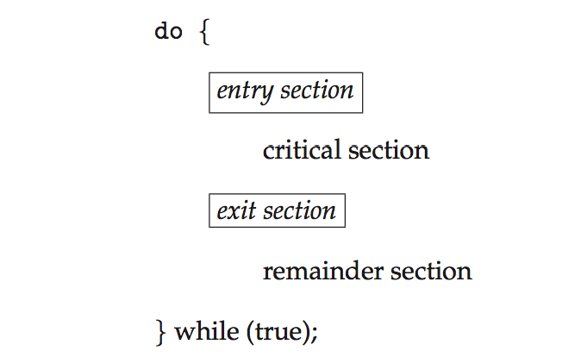  Producer Consumer Problem:  - The producer should produce data only when the buffer is not full. In case it is found that the buffer is full, the producer is not allowed to store any data into the memory buffer.  - Data can only be consumed by the consumer if and only if the memory buffer is not empty. In case it is found that the buffer is empty, the consumer is not allowed to use any data from the memory buffer.  - Accessing memory buffer should not be allowed to producer and consumer at the same time.  Producer Code Consumer Code  - 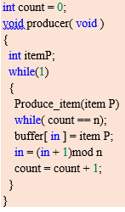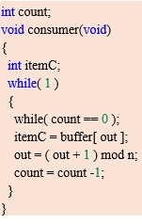 | 10 | 3 | 1 | 3 | 3.6.2

